

2026 LeadingAge Missouri
May 18-20, 2026
Margaritaville
Lake Ozark, Missouri

Annual Conference + EXPO
Exhibitor Prospectus

Welcome to an event like no other! This year, we’re not just gathering, we’re igniting ideas, sparking connections, and setting the stage for breakthroughs that will shape the future. Get ready for powerful insights, dynamic conversations, and moments that will leave you inspired and energized. This is your chance to be part of something extraordinary—let’s make it unforgettable!

Conference Overview

The Change Makers Conference is an event designed to ignite your potential! This year, we’re bringing together bold thinkers, passionate leaders, and innovators ready to shape the future. This is more than a conference, it’s a movement. Every session is an opportunity to learn, grow, and push boundaries. You’re invited here because you have the power to make an impact, and together, we’ll turn ideas into action. Let’s embrace this moment and create something extraordinary!
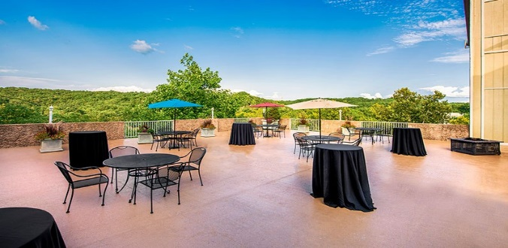
Tentative Conference Agenda
Sunday, May 17th
3pm – 5pm Registration Open/Vendor set-up
5:00pm – 6:30pm Welcome Reception

Monday, May 18th
7:00 am to 5:30 pm Registration Open
7:30 am to 8:30 am Grab and Go Breakfast
8:00 am to 11:00 am Education- Opening Sessions
11:00 am to 12:00 pm Exhibits Open with CEU Opportunities
12:00 pm to 1:30 pm Awards Luncheon
1:00 pm to 4 pm Learning through engagement (Resort Activities open)
5:30pm-7:00pm Game Night

Tuesday, May 19th
7:30 am to 5:00 pm Registration Open
7:00 am to 8 am Breakfast in Exhibit Hall
8:00 am to 10:45 am Education Sessions
11:30 pm to 12:30 pm Exhibits Open with CEU Opportunities
12:30 pm to 1:30 pm Lunch w/ Exhibitors (Giveaways (optional) starting at 12:30pm)
1:30 pm to 5:00 pm Education Sessions
1:30 pm to 5:00 pm Exhibitor Tear Down
5:00 pm to 7 pm Hospitality Hop with Exhibitors/Sponsors

Wednesday, May 20
7:30 am to 8:30 am Member Breakfast
8:30 am to 11:45 am Education Sessions
11:45 am Adjourn

BECOME AN EXHIBITOR
Exhibit Booth Details

Standard booths are 10’ deep x 10’ wide; multiple booths may be purchased. Booth includes table, two chairs, wastebasket. The ballroom floor is carpeted, and the ceiling is 9’ high. Electricity and all marketing material are the responsibility of the exhibitors. All booths will be set up ISLAND style.

Booth Assignments

It is understood and agreed that all space will be assigned on a first-come, first-served basis determined by the date of receipt of contract and full payment. LeadingAge Missouri reserves the right to change the booth floor plan and booth locations at any time. LeadingAge Missouri reserves the right to assign exhibitors the best alternate space if the first three choices are already reserved and to make reasonable shifts in location. Each exhibiting company is required to insure itself against property loss or damage and against liability for personal injury.

Booth Fees & Cancellation Policy
Booth rental fee includes:
- Payment of the 10 x 10 booth space
- Exhibit hall passes for two booth staff for trade show (additional passes $50.00 each)
- Sunday Evening Welcome Reception (Patio)
- Monday Awards Luncheon (Limit 2)
- Monday evening game night (5:30pm-7pm)
- Tuesday evening Hospitality Hop (Limit 5)
- Lunch for two booth staff in exhibit hall on Tuesday

Booth Fees
Standard Booth $850 Member $1,425 Non-Member

Booth Furnishings
Table, 2 chairs, wastebasket, table covering

An exhibitor’s service kit which will be emailed with your booth confirmation.

The entire booth rental fee must accompany the contract. A refund will be made, less a 25% handling fee, if the cancellation is received in writing prior May 1, 2026. Cancellations after this date or failure to participate in the show will result in forfeiture of the entire fee. Non-payment of space after this deadline will be interpreted to mean that the exhibiting company no longer wishes to reserve space and LeadingAge Missouri reserves the right to sell this space to another company.

The non-member exhibiting fee includes $575 LeadingAge Missouri membership for the remainder of calendar year 2026

Contractor Services
Margaritaville Show Services will be providing exhibitor set up and services. Service kits will be available in April and links will be emailed to exhibitors with their booth confirmation.

All materials will need to be shipped to Margaritaville. Shipping information will also be included in exhibitor packet. If you have immediate questions regarding decorator order, please contact Margaritaville Services at

Publicity
Exhibitors who register and pay in full by April 30, 2026 will be recognized in the LeadingAge Missouri newsletter and on-site program. Ads and Logos must be received by April 30, 2026 to be included in the on-site program.
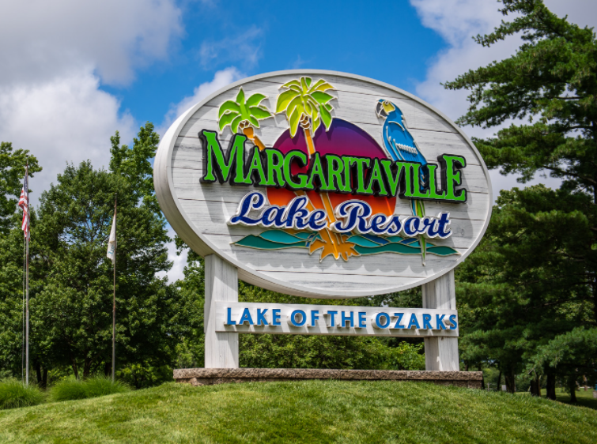

FLOORPLAN

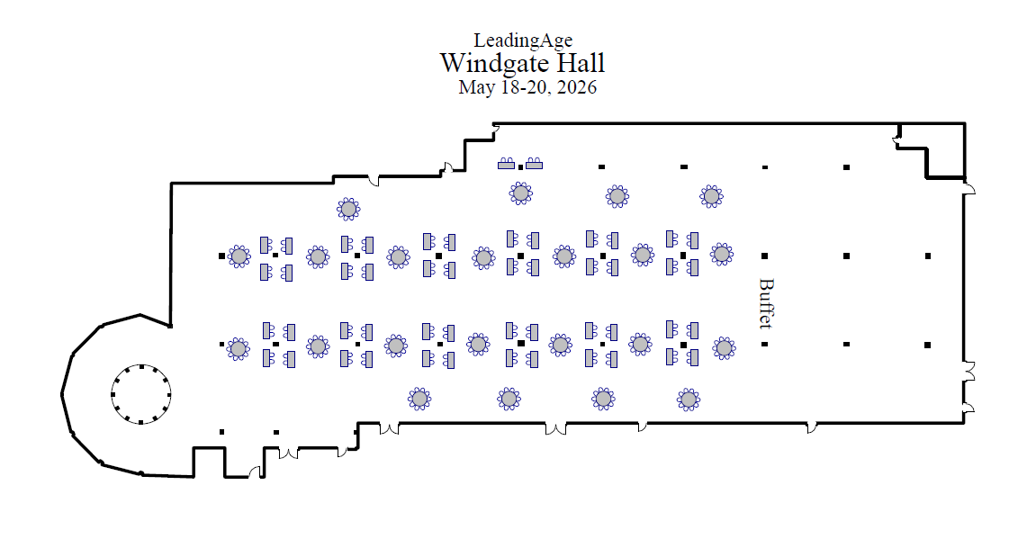

Liability
The exhibitor assumes the entire responsibility and liability for losses, damages and claims arising out of the exhibitor’s activities on Hotel premises and will indemnify, defend and hold harmless the Hotel, its owner(s), its management company and LeadingAge Missouri, as well as their respective agents, servants and employees from any and all such losses, damages and claims.

Additional Sponsorship Opportunities

All sponsorship opportunities are on a first-come, first-serve basis determined by the date of receipt of contract and full payment. All sponsorship opportunities come with a ½ page (Max. 7 ½” wide x 5” high) interior ad in the program brochure to maximize exposure at the 2026 LeadingAge Missouri Annual Conference, the following sponsorship opportunities are available:

Opportunity | Investment | Benefits
Registration Sponsor | $2,500 | Opportunity for signage at Registration Desk, recognition in the Missouri Messenger Newsletter.
Hospitality Hop | $850 (sponsor provides room and food) | Opportunity to meet attendees 1 on 1 in your hotel space set up as a hospitality room. These will be our Tuesday (May 19th) evening activities. You will receive signage at conference, verbal recognition throughout conference and recognition in monthly LeadingAge Missouri Messenger Newsletter
Reception Sponsor  (4 Available) | $3,500 | Opening remarks and introductions at one of two receptions, (Sunday, May 17th or Monday, May 18th). You will receive signage at conference, verbal recognition throughout conference and recognition in monthly LeadingAge Missouri Messenger Newsletter
Resort Activities  (3 Available) | $3,000 | Opportunity to sponsor resort activity events, Monday May 18th (1:30pm-4pm) Opportunities available Bowling center, Mini Golf Course, Indoor Waterpark). You will receive signage at conference, verbal recognition throughout conference and recognition in monthly LeadingAge Missouri Messenger Newsletter
Event Program Sponsor | $2,500 | One complimentary conference education registration, signage at conference, verbal recognition throughout conference and recognition in monthly LeadingAge Missouri Messenger.
Luncheon Sponsor  (2 Available) | $3,000 | Opening remarks and introductions at one of two luncheons, (exhibit hall lunch or awards lunch), signage at conference, verbal recognition throughout conference and recognition in monthly LeadingAge Missouri Messenger Newsletter
Member Breakfast  (2 Available) | $3,500 | Opening remarks and introductions at breakfast, signage at conference, verbal recognition throughout conference and recognition in monthly LeadingAge Missouri Messenger Newsletter
Keynote Speaker  Sponsor | $5,000 | Opening remarks and introductions, signage at conference, verbal recognition throughout conference and recognition in monthly LeadingAge Missouri Messenger Newsletter
Custom | ?? | Come with your unique ideas for the LeadingAge Missouri conference?

BECOME AN ADVERTISER

Advertising in LeadingAge Missouri’s on-site program is an excellent way to reinforce your commitment to this conference. It is also a great way to have a presence if you are unable to participate in other ways.

All conference attendees receive an on-site program. The 8.5” x 11” brochure will include general conference information, a conference agenda with course description, a listing of award winners, a listing of exhibitors and a listing of conference sponsors.
Note: The on-site brochure and planner will display exhibitors and sponsors paid as of April 30, 2026.

Full page, full color ad spaces are inside the front cover, inside the back cover and on the outside back cover.

Opportunity | Amount | Details
Outside Back Cover (full page) | $800 | Max. 7 ½” wide x 10” high
Inside Front Cover (full page) | $800 | Max. 7 ½” wide x 10” high
Inside Back Cover (full page) | $700 | Max. 7 ½” wide x 10” high
Interior Full Page | $500 | Max. 7 ½” wide x 10” high
Interior Half Page | $250 | Max. 7 ½” wide x 5” high

LeadingAge Missouri reserves the right to select the pages banners ads placement. Error-free digital files, jpg only, should be sent to rebekahlucas@leadingagemissouri.org.

Lodging

Margaritaville Lake Ozark
494 Tan Tar A Drive
Osage Beach, MO 65065

You may visit their website at https://www.margaritavilleresortlakeoftheozarks.com/ to learn more about the hotel’s amenities. The conference hotel room rate is $149.00 plus state and lodging tax for a single/double occupancy room. To ensure the conference rate, you must make your reservations by April 17, 2026. This is a strict deadline. Make your reservations by calling the Margaritaville toll free at (800) 826-8272 or by clicking here: LeadingAge Missouri 2026. If calling, be sure to mention you are with the LeadingAge Missouri conference to receive this special rate.

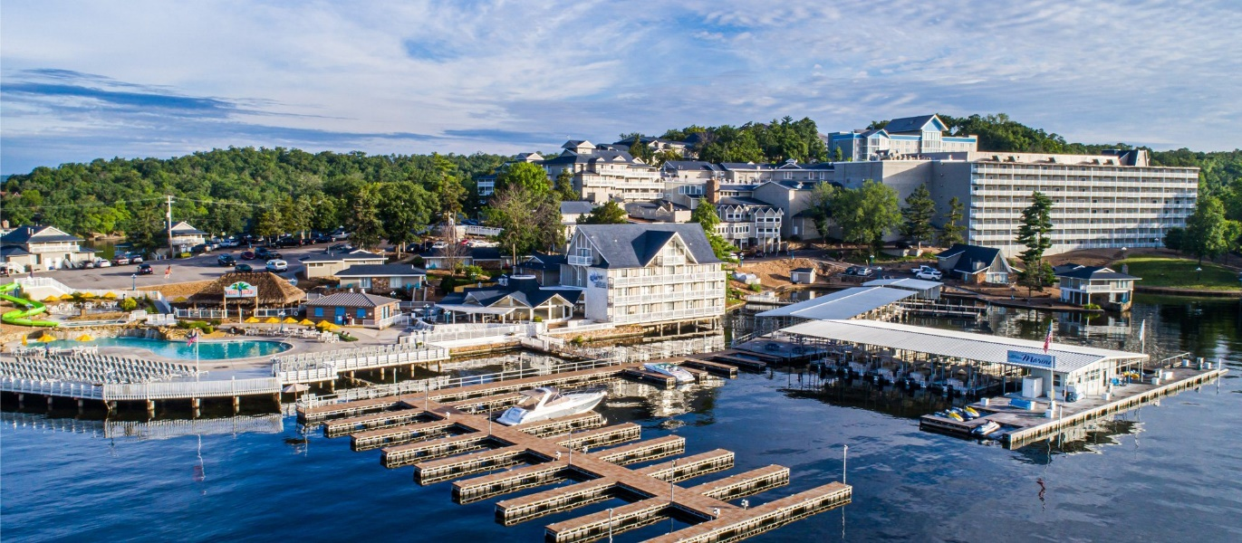

LeadingAge Missouri 2026 Annual Conference + EXPO
Exhibitor/Sponsorship/Advertising Request Form
(Please type or print clearly.)

Organization: __________________________________ Contact Person: _________________________
Mailing Address: _______________________________ City/State/Zip: ___________________________

Website: _____________________________________ Contact Person’s Phone: __________________
Contact Person’s E-Mail: _____________________________ Fax: ______________________________
For On-Site Program: Please list company name, representative, address, phone number and e-mail address as it should appear in the final program, if different from above:
________________________________________________

Preferred booth location: 1st _________, 2nd _________, 3rd _________ (exhibit layout follows PAGE 4)
List companies you do not wish to be placed near:

Please provide, in 20 words or less, a description of your products and/or services to be published in the on-site brochure. Please TYPE or PRINT CLEARLY. LeadingAge Missouri reserves the right to edit any material.

If you are registering for an Exhibit Booth, please indicate the following:

Exhibit hall passes for booth workers 1 and 2 FREE

Name of attendee: ___________________ Name of attendee #2:

Exhibit hall passes for additional workers @ $50.00 each x = $

Name(s) of additional attendee:

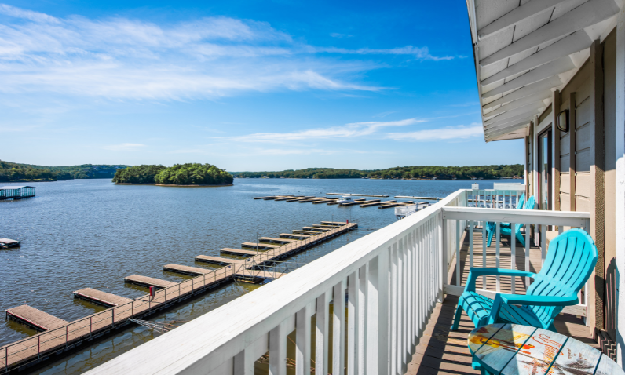

Please check all that apply to your organization:

Sponsorship, check all that apply

Check | Opportunity | Cost | Quantity | Total Cost
 | Registration Sponsor | $2,500
 | Hospitality Hop (5 Available) | $850
 | Reception Sponsor (2 Available) | $3,500
 | Resort Activities | $3,000
 | Event Program Sponsor | $2,000
 | Luncheon Sponsor  (2 available) | $3,000
 | Member Breakfast | $3,500
 | Keynote Speaker | $5,000
 | Custom
 | GRAND TOTAL

Advertisements check all that apply

Check | Opportunity | Cost | Quantity | Total Cost
 | Outside Back Cover (full page) | $800
 | Inside Front Cover (full page) | $800
 | Inside Back Cover (full page) | $700
 | Interior Full Page | $500
 | Interior Half Page | $250
 | GRAND TOTAL

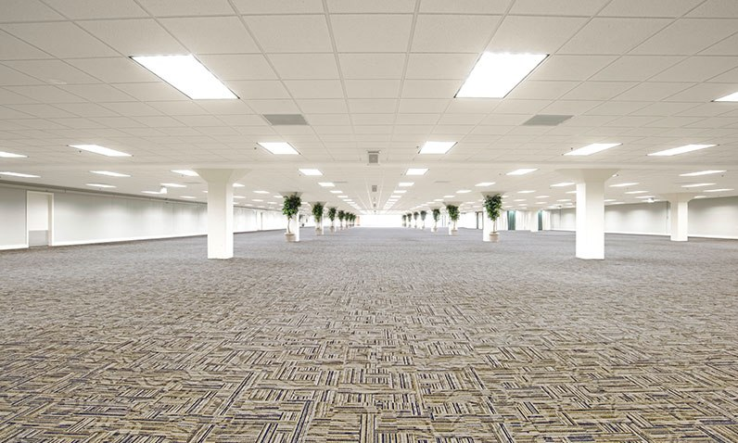

TOTAL PAYMENT $ ____________ 
Company Name: ________________________________________________________

Type of Payment: Check Visa AMEX MasterCard CVC Code: ______________

Credit Card # Exp. Date:

Signature: _____

Please PRINT name on card:

Billing address for card:

The terms and conditions printed in the Exhibitor Prospectus/Sponsor/Advertising Opportunities brochure are hereby incorporated by reference and we agree to be bound by them. We agree that the booth space assigned shall be accepted by us. LeadingAge Missouri is authorized to reserve exhibit space as indicated above for use by our organization. All sponsorship opportunities are on a first-come first-served basis. You will be notified if the sponsorship you requested has already been reserved.

Signature: Date:

Make checks payable to LeadingAge Missouri and mail with completed application to:

LeadingAge Missouri, 3412 Knipp Drive, Suite 102, Jefferson City, MO 65109.

Applications and questions may be e-mailed to rebekahlucas@leadingagemissouri.org
Online payment is available at www.leadingagemissouri.org

Thank you for supporting LeadingAge Missouri and our members!!


