

May 18-20, 2026
Margaritaville
Lake Ozark, Missouri

2026 LeadingAge Missouri
Annual Conference + EXPO
Attendee Brochure

Welcome to an event like no other! This year, we’re not just gathering, we’re igniting ideas, sparking connections, and setting the stage for breakthroughs that will shape the future. Get ready for powerful insights, dynamic conversations, and moments that will leave you inspired and energized. This is your chance to be part of something extraordinary—let’s make it unforgettable!

Conference Overview

The Change Makers Conference is an event designed to ignite your potential! This year, we’re bringing together bold thinkers, passionate leaders, and innovators ready to shape the future. This is more than a conference, it’s a movement. Every session is an opportunity to learn, grow, and push boundaries. You’re invited here because you have the power to make an impact, and together, we’ll turn ideas into action. Let’s embrace this moment and create something extraordinary!

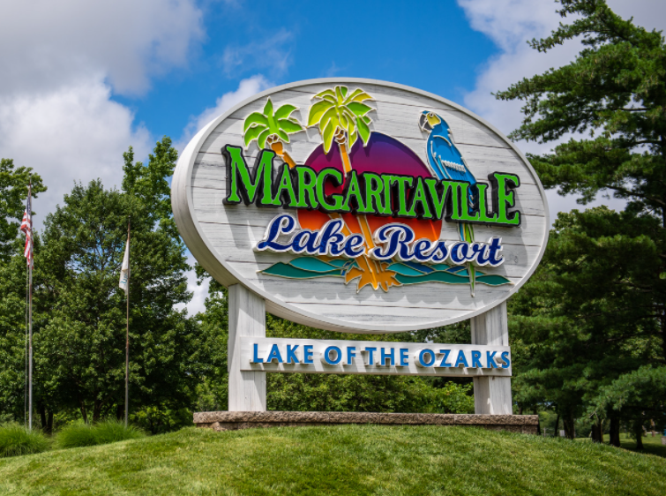
Tentative Conference Agenda

Sunday, May 17
3pm – 5pm Registration Open
5:00pm – 6:30pm Welcome Reception

Monday, May 18
7:00 am to 5:30 pm Registration Open
7:30 am to 8:30 am Grab and Go Breakfast (Paradise C)
8:00 am to 11:00 am Education- Opening Sessions
11:00 am to 12:00 pm Exhibits Open with CEU Opportunities
12:00 pm to 1:30 pm Awards Luncheon
1:30 pm to 4:00 pm Learning through engagement (Resort Activities open)
4:30pm to 5:00pm Education Session
5:30pm-7:00pm Game Night

Tuesday, May 19
7:30 am to 5:00 pm Registration Open
7:00 am to 8:00 am Breakfast in Exhibit Hall
8:00 am to 10:45 am Education Sessions
11:30 pm to 12:30 pm Exhibits Open with CEU Opportunities
12:30 pm to 1:30 pm Lunch w/ Exhibitors (Giveaways starting at 12:30pm)
1:30 pm to 5:00 pm Education Sessions
5:00 pm to 7:00 pm Hospitality Hop with Exhibitors/Sponsors

Wednesday, May 20
7:30 am to 8:30 am Member Breakfast
8:30 am to 11:45 am Education Sessions
11:45 am Adjourn

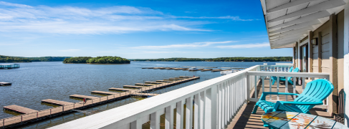
Education Sessions (at a glance)

Monday
Keynote – Jack York – the power of engaged life in Senior Care
Breakout Sessions – Great Culture starts with HR – a case study by Friendship Village. Clinical Education with the Midwest QIN/QIO
Exhibit Time
Learning through Engagement – Resort activities open to engage with peers in a different environment.

Tuesday
LeadingAge Missouri Education
Learning through Growth – A case study with The Baptist Homes
Fair Housing
Exhibit Time
Clinical Education
Home Health or Private Duty Nursing – Know the differences (Panel)
The power of Therapy Animals – Walkers Gone Wild (there will be various small animals in attendance, ex. monkeys)

Council for In-Home Services all Day Track
Education in the HCBS environment – more details to come

Wednesday
Carmen Bowman
DHSS Regulator Updates

We welcome you to attend the Welcome Reception Sunday night on the patio!

We have several social events planned for networking and fellowship! Game night, Hospitality Hop, Awards Luncheon, learning through engagement to enjoy resort activities, member breakfast and time with exhibitors.
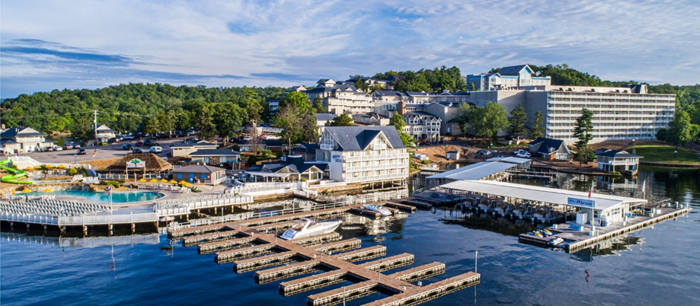
BECOME AN ATTENDEE

Opportunity | Investment | Benefits
Member Attendee  Full Conference | $450 | Full conference attendance including all social activities, meals and access to Council for In-Home Services Education.  Special! Until April 1st – For every 10 attendees registered per organization – get 1 free!
Non-Member Attendee Full Conference | $550 | Full conference attendance including all social activities, meals and access to Council for In-Home Services Education.  Special! Schedule a membership meeting to receive member pricing!
Monday Attendee | $250 | Monday Education Sessions including all social activities and meals
Tuesday Attendee | $250 | Tuesday Education Sessions including all social activities, meals and access to Council for In-Home Services Education.
Wednesday Attendee | $150 | Wednesday Education Sessions including member meeting and meals
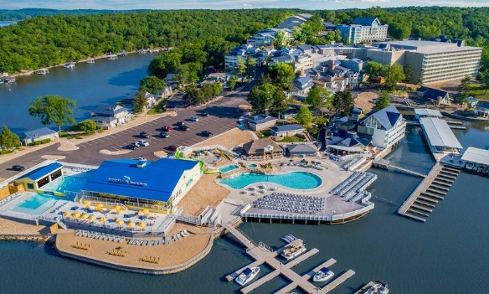
Lodging

Margaritaville Lake Ozark
494 Tan Tar A Drive
Osage Beach, MO 65065

You may visit their website at https://www.margaritavilleresortlakeoftheozarks.com/ to learn more about the hotel’s amenities. The conference hotel room rate is $149.00 plus state and lodging tax for a single/double occupancy room. To ensure the conference rate, you must make your reservations by April 17, 2026. This is a strict deadline. Make your reservations by calling the Margaritaville toll free at (800) 826-8272 or by clicking here: LeadingAge Missouri 2026. If calling, be sure to mention you are with the LeadingAge Missouri conference to receive this special rate.

LeadingAge Missouri 2026 Annual Conference + EXPO
Attendee Registration
(Please type or print clearly.)

Organization: __________________________________ Attendee: _______________________________
Mailing Address: _______________________________ City/State/Zip: ___________________________

Attendee’s Phone: _______________________________ Administrator #:______________________
Attendee’s E-Mail: __________________________________________________________

TOTAL PAYMENT $ ____________
Type of Payment: Check Visa AMEX MasterCard CVC Code: ______________
Credit Card # ___________________ Exp. Date:

Signature: _____

Please PRINT name on card:

Billing address for card:

Cancellation Policy: LeadingAge Missouri will refund 100% of payment (less bank fees) if cancelled by April 15th, 2026. Any cancellation after this is not subject to refund, but you may send a substitute.

Signature: Date:

Make checks payable to LeadingAge Missouri and mail with completed registration to:
LeadingAge Missouri, 3412 Knipp Drive, Suite 102, Jefferson City, MO 65109.
Registrations and questions may be e-mailed to rebekahlucas@leadingagemissouri.org

